Name 1____________________
Name 2____________________
For this assignment you may work in PAIRS but no more than two people per group!
Act I Scene 3 of Hamlet is where we first truly see the dynamics within Polonius’ family. As Laertes prepares to leave for college in France, he leaves Ophelia with advice. Then he receives advice from his own father.
- What is Laertes’s advice to Ophelia regarding Hamlet? Is it good advice? Why?

- Make a list of Polonius’ advice to Laertes concerning the following values--
Money:

Love:

Appearances:

Friendship:

Entertainment:
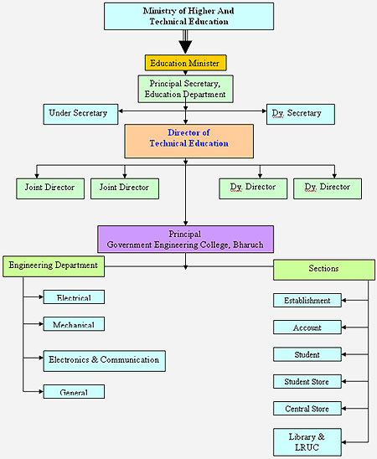
- “This above all…” Make a chart of Polonius’s advice regarding values that shows hierarchy based on your opinions as well as his. Make sure to add WHY things go where they do.
It should be similar to this concept:

Use scratch paper that I’ll provide. Make it neat, readable, and usable.

- The plot of Hamlet revolves around two families, the royal family Hamlet Senior-Hamlet-Gertrude-Claudius as well as Polonius-Laertes-Ophelia. There are two sets of fathers, and two sets of children.
It’s possible that these two families are FOILS to each other. In literature, a foil is a character that shows qualities that are in contrast with the qualities of another character with the objective to highlight the traits of the other character. What we observe in literature very often is that a foil is a secondary character who contrasts with the major character to enhance the importance of the major character.
For the following question, collaborate with your partner to write a short answer response (begin with thesis, include evidence and analysis, 5-7 sentences). Use separate paper if necessary.

Sure, it’s still early in the play—but so far, how are these characters, and the dynamics within their families, acting as foils to each other?

