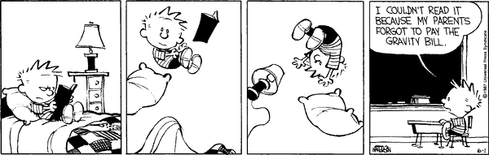

Choose a book at an appropriate reading level for the grade that you want and read it. Your product, or report, will be a double-entry log of at least ten entries with citations that comprise important information from all parts of the book. This book must be a book you haven’t read before. You may not “double dip” books with reading material for other classes.
Book reports will be graded on difficulty of the book as well as the log. If your log meets all criteria, then the book will earn the following scores based on Lexile.
I want to earn: | I can read a book with these Lexile measures:
A 90-100% | 990-1100L +
B 80-89% | 880L-989L
C 70-79% | 770L-879L
D 60-69% | 660L-769L

- The Lexile rating system is imperfect--if you have a question regarding the difficulty of your reading book, please see me.
- You may still read books with a lower Lexile score, but will need to either settle for a lower grade or read an additional book.
- Books must be at least 100 pages in length
- If the book is over 450 pages but has a lower score, it may count as a second book if you add at least 8 additional entries to your log.
- Find out the Lexile score of your book at: http://www.scholastic.com/bookwizard/
- If your book’s score isn’t listed, use https://lexile.com/analyzer/ to determine the score of your book by uploading a .txt (plain text) version of up to 1000 words of your book. It is not your teacher’s responsibility to do this for you. You may use Miss Watson’s login info: username: amwatson@dsdmail.net and password: nuames
- Some books will be disallowed for book reports because of overuse and likelihood of cheating.
- Those titles include, but are not limited to: The Twilight series The Hobbit The Fault in Our Stars Nicholas Sparks novels The Divergent series Manga The Hunger Games series Un-Published Fan Fiction
- Put only one log entry in each box and use each form for only one book.
- A sample Double-Entry Log is on the next page. You may use it as a template if you download the form from my website or create your own with all the same information on it.
This assignment is due on May 15. No late submissions will be allowed.
Name:
Period:
Date Submitted:
Total Score: __________ /80
Lexile Score Adjustment _______

Title of Book:
Author:
Number of Pages Read and Total in Book:
(5 pts)
Lexile Score: If negotiated score, teacher’s initials:
Lexile Score Source: (5 pts)

Complete APA Citation:

(5 pts)
Short Summary of Book:

(5 pts)
Page  (-1 pt each if missing) | Importation Quotations: | In-depth Analysis:  (6 pts each X 10)

